Project 1: Martingale  
CS7646

Zixin Feng   
zfeng305@gatech.edu

***Abstract—***This is Zixin Feng’s report of project 1. The project topic is Martingale.

# Qestions

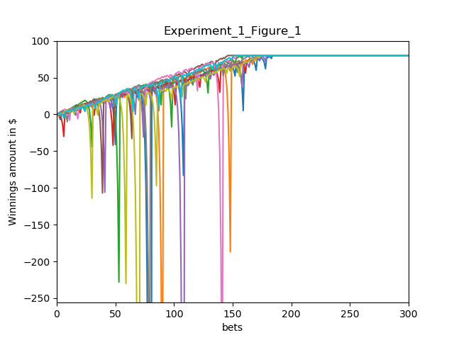

1. Plot of the winning amount of the top 30 bets of 10

episodes.

## Question 1

According to the graph, nearly all episodes get to $80 at around 160 bets.

Why is this happening? Let us set the initial amount to be n. Once we lose, the bet amount doubles. Even if we continuously lose, the first win after all losses will easily bring our winnings to n+1. In this way, we will have more and more money after making enough bets.

As a result, we have nearly 100% chance to get to $80.

Let us try to calculate the probability of unable to reach $80. Let us set n+1 to be the largest number that is smaller than 80, which is 79. When n = 78, we win 79 times and therefore lose 921 times. The probability to lose 921 times is (20/38) ^ 921, which is nearly zero.

## Question 2

The expectation is simply $80. According to the expectation equation, the total expectation equals to the probability of each winning amount times the winning amount. In our case, there is only one winning amount, which is 80 so 80 * 1 = $80.

## Question 3

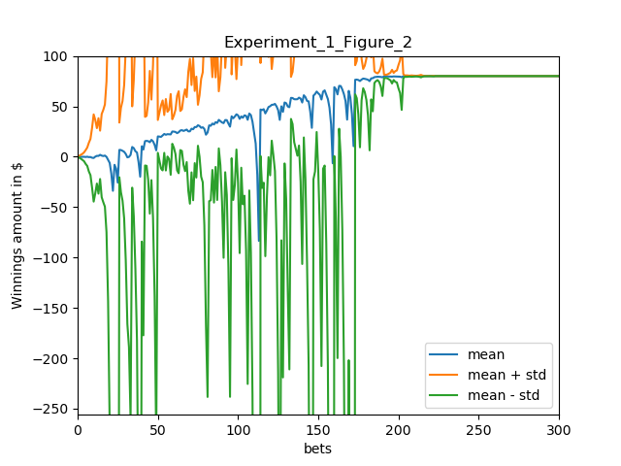

1. Plot of the average winning amount of 1000 episodes in Experiment 1

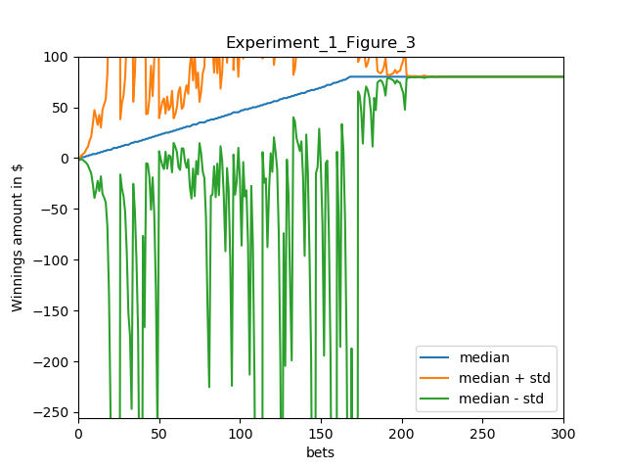

1. Plot of the median winning amount of 1000 episodes in Experiment 1

According to the graph, the upper standard deviation line and lower standard deviation line first diverge while the number of sequential bets increases and then stabilize at the mean line $80 at around 160 bets.

The reason is that as the number of bets increases, the bet amount can be big when there is continuous loss, and because of that, the standard deviation is very large. However, after about 160 bets, the total winnings reach the upper limit and stabilizes. As a result, the standard deviation becomes zer0 and 3 lines cover each other.

## Question 3

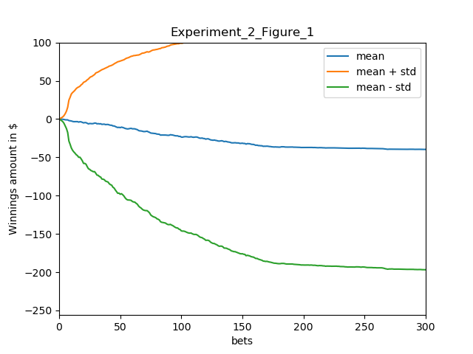

1. Plot of the average winning amount of 1000 episodes in Experiment 2

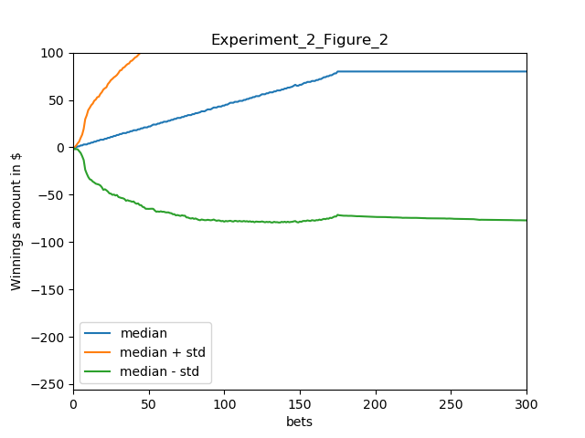

1. Plot of the median winning amount of 1000 episodes in Experiment 2

In Experiment 2, we observe many episodes end up with either $80 or $-256. We observed there are 641 episodes that reach $80 so the estimated probability of 64.1%.

## Question 5

According to Question4, we observe there are 641 episodes that reach $80 and 1000-641 episodes that reach $256. As a result, the expected value is simply:

0.641 * 80 + (1-0.641) * -256 = $-40.624

The mean stabilizes around at $-40.624 too.

## Question 6

The mean stabilizes around $-40.624. The upper deviation reaches maximum and then stabilize. The lower deviation also reaches minimum and the stabilize around 175 bets. Two lines diverge farther and farther as the number of sequential bets increases.

With number of bets increases, the standard deviation gets larger because the bet amount gets larger. However, after about 175 bets, most episodes either reach $80 or $-256. As a result, the std reduces to zero gradually.

## Question 7

By running enough number of experiments, we won’t be easily influenced by extreme cases. Instead, we will have a good sense of which outcome is mostly likely to happen and the corresponding value of the most likely outcome.